Queena Lin

CIS 310-02

Homework 9

Note that the ASSIGNMENT table in [Figure P7.1](javascript://) stores the JOB_CHG_HOUR values as an attribute (ASSIGN_CHG_HR) to maintain historical accuracy of the data. The JOB_CHG_HOUR values are likely to change over time. In fact, a JOB_CHG_HOUR change will be reflected in the ASSIGNMENT table. Naturally, the employee primary job assignment might also change, so the ASSIGN_JOB is also stored. Because those attributes are required to maintain the historical accuracy of the data, they are not redundant.

1. Write the SQL code required to list the employee number, last name, first name, and middle initial of all employees whose last names start with Smith. In other words, the rows for both Smith and Smithfield should be included in the listing. Sort the results by employee number. Assume case sensitivity.

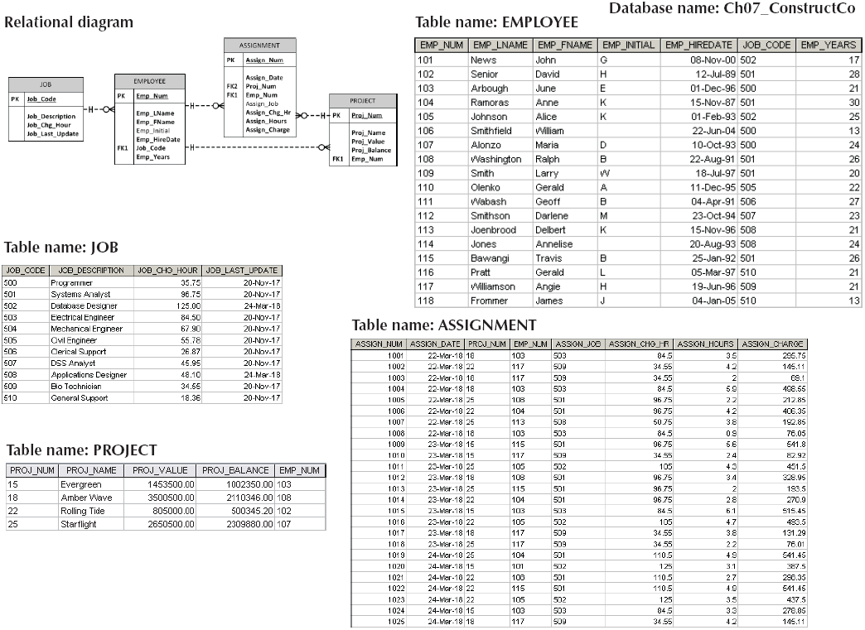

**SELECT** EMP_NUM, EMP_LNAME, EMP_FNAME, EMP_INTIAL

**FROM** EMPLOYEE

**WHERE** EMP_LNAME=’Smith’

**ORDER BY** EMP_NUM;

1. Using the EMPLOYEE, JOB, and PROJECT tables in the Ch07_ConstructCo database, write the SQL code that will join the EMPLOYEE and PROJECT tables using EMP_NUM as the common attribute. Display the attributes shown in the results presented in [Figure P7.2](javascript://), sorted by project value.

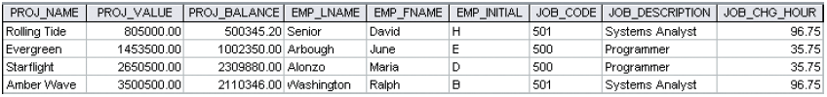

**SELECT** PROJ_NAME, PROJ_VALUE, PROJ_BALANCE, EMPLOYEE. EMP_LNAME, EMP_FNAME, EMP_INITIAL, EMPLOYEE. JOB_CODE, JOB. JOB_DESCRIPTION, JOB. JOB_CHG_HOUR

**FROM** PROJECT, EMPLOYEE, JOB

**WHERE** EMPLOYEE.EMP_NUM = PROJECT.EMP_NUM

**AND** JOB.JOB_CODE = EMPLOYEE.JOB_CODE

**ORDER BY** PROJ_VALUE;

1. Write the SQL code that will produce the same information that was shown in [Problem 2](javascript://), but sorted by the employee’s last name.

**SELECT** PROJ_NAME, PROJ_VALUE, PROJ_BALANCE, EMPLOYEE. EMP_LNAME, EMP_FNAME, EMP_INITIAL, EMPLOYEE. JOB_CODE, JOB. JOB_DESCRIPTION, JOB. JOB_CHG_HOUR

**FROM** EMPLOYEE JOIN JOB USING PROJECT

**WHERE** EMPLOYEE.EMP_NUM = PROJECT.EMP_NUM

**AND** JOB.JOB_CODE = EMPLOYEE.JOB_CODE

**ORDER BY** EMP_LNAME;

1. Using the data in the ASSIGNMENT table, write the SQL code that will yield the total number of hours worked for each employee and the total charges stemming from those hours worked, sorted by employee number. The results of running that query are shown in [Figure P7.6](javascript://).

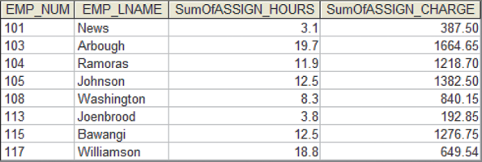

**SELECT** ASSIGNMENT.EMP_NUM, EMPLOYEE.EMP_LNAME, Sum(ASSIGNMENT.ASSIGN_HOURS) AS SumOfASSIGN_HOURS, Sum (ASSIGNMENT.ASSIGN_CHARGE) AS SumOfASSIGN_CHARGE

**FROM** EMPLOYEE, ASSIGNMENT

**WHERE** EMPLOYEE.EMP_NUM = ASSIGNMENT.EMP_NUM

**GROUP BY** ASSIGNMENT.EMP_NUM, EMPLOYEE.EMP_LNAME;

7. Write a query to produce the total number of hours and charges for each of the projects represented in the ASSIGNMENT table, sorted by project number. The output is shown in [Figure P7.7](javascript://).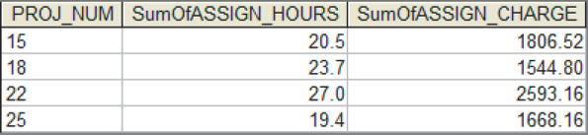

**SELECT** ASSIGNMENT.PROJ_NUM, Sum (ASSIGNMENT.ASSIGN_HOURS) AS SumOfASSIGN_HOURS, Sum (ASSIGNMENT.ASSIGN_CHARGE) AS SumOfASSIGN_CHARGE

**FROM**  ASSIGNMENT

**GROUP BY** ASSIGNMENT.PROJ_NUM;